Ian Highet was a Radio Officer in the British Merchant Navy. He completed a nine-month course in Radio Telegraphy at the Glasgow Radio College in September 1942. Shortly after his eighteenth birthday, he joined his first vessel, the Empire Snow, as part of a convoy to Murmansk.
Ian served on several ships and in many war zones during World War II. He was not one for telling “war stories” but his family believes that three of the ships on which he served were attacked and damaged so badly that the crews had to abandon ship.
During the 1970s he rekindled his interest in shortwave radio, and enjoyed listening to Radio Moscow, Radio Prague and Radio Hilversum. He wrote the following article in August 1975 and sent it to Radio Moscow, which was then celebrating the 30th anniversary of victory in World War II and paying tribute to those from distant lands, the servicemen and the shipyard and factory workers, who had contributed to that victory.
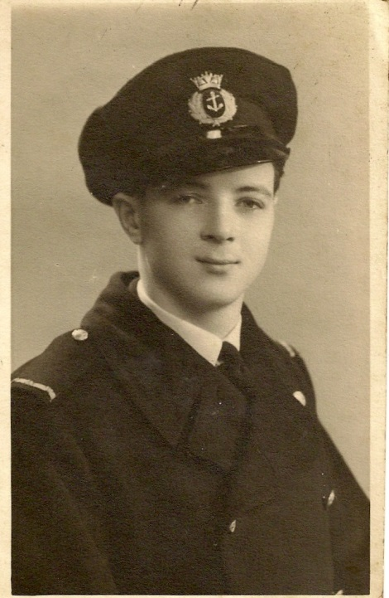
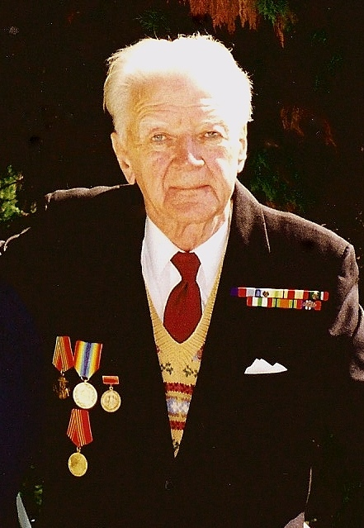

DESTINATION MURMANSK

By the end of 1942 the Soviet armed forces had halted the march of Fascism and demonstrated to the world their determination to defend their motherland and crush the Nazi invader. It was at this turning point of the war that a few ships left the River Tyne on Friday, 13 January 1943 (an ominous date for the superstitious) to rendezvous with a much larger contingent from the more industrial west coast of the British Isles that was going north about – our destination Murmansk.
We rendezvoused on time, assembled in battle array, and set a north-easterly course into all the hazards that our two-day survival school had advised us to expect – intense enemy activity coupled with the bitter cold associated with latitudes north of 66° 30’, the Arctic Circle. In the meantime, the Red Army was facing the most intensive enemy activity in sub-zero temperatures and paying a terrible price.
Every crew member on the 32 cargo ships assembled had heard of the famous (or infamous) September 1942 convoy, wherein only a handful survived. I understand that of the 48 ships in that convoy, only 4 cargoes arrived intact. In men, tonnage and cargoes, the toll was enormous. The frozen bodies, sunken ships and lost cargoes stand testimony to this. History was to prove that the convoy of January ’43 was to be somewhat different at least outward bound and, by a twist of fate, we were to deliver 30 cargoes of war material down the Kola River to the port of Murmansk.
The Norwegian and Barents Seas were never kind to seafarers in the month of January. The weather was far from being good.
In the Norwegian Sea (halfway in the voyage) as Radio Officer I recall detecting a signal of groups of “JJJJ” interspersed with other meaningless groups, indicating that the enemy was now aware of our position (this form of listening was the prime task of our radio room – the monotonous task of scanning the 600-800 metre frequencies to listen for something you hoped never to hear). A bearing was taken, which showed the signal to emanate from astern of the convoy. The bridge was alerted and every pair of binoculars was scanning aft for an aircraft or surface vessel.
In that bitter cold, it was a Scottish gunner on our lower bridge who sounded out loud and clear “Enemy aircraft starboard quarter … estimated range 5 miles … estimated height 1,500 feet … Blohm und Voss!” The appropriate signal was despatched to the Commodore (KMD 1) and a destroyer fell out of line to engage. I don’t recall the outcome of this engagement in detail but Berlin knew where we were. This was not good news, and I remember the discussions that this could be September ’42 all over again.
And it may well have been but for the fact that the Arctic turned on what was possibly the foulest weather in its history – seas at the height of 200 feet and a wind force of 80 knots blowing off the polar cap, augmenting itself at times to gusts of up to 100 knots. In these circumstances, one could watch the mercury fall from a nominal minus 45° to minus 50°C. As the Canadian poet Robert Service wrote in his “Cremation of Sam McGee”, “… Talk of your cold! through the parka’s fold it stabbed like a driven nail”. Those on a weather deck were reduced to crawling along an icicled life-line to the monotonous howl of an Arctic wind.
In such a situation one’s mind harkened back to the Malta convoys – never a picnic, but there at least the water was warm and one’s chance of survival rated in days, not minutes – or further east to the Persian Gulf where in September the date wind blows off the desert, dehydrating everything in its path, the mercury reading 60°C and hygrometer reading zero, but at least there a man could raise a thirst. In the Barents in January ’43 the only thirst was to survive.
Because of the January ’43 weather, Admiral Doenitz and Field Marshall Goering were unable to chuckle over their stolen French cognac as they did in September ’42 when they massacred a convoy. Mother Nature had rendered their Fascist forces useless. Conversely, of course, it was not plain sailing for us, and our three rescue tugs, which had been doing everything short of somersaults, had to be sent back.
Despite this situation we were able to deliver 30 of 32 cargoes to the Russian Front – a loss of only two ships.
I think I should make some mention here of how those two ships were lost. In a few hours of daylight and a temporary lapse in the weather, a U-boat was able to penetrate the outer and inner screens of the escort. The first to go was a tanker (American); she disappeared in one vivid flash leaving nothing to suggest that there had ever been a ship there – aviation spirit. I remember being on the bridge at the time and feeling this momentary blast of warm air, seeing the officer of the deck vomit a hastily eaten meal but remain on duty to direct the activities of the ship. Within minutes our port beam ship shot up a column of black smoke that was succeeded by a series of explosions which wracked her hull from stem to stern – disintegrating and disappearing – an ammunition ship (British). From either vessel there could have been no survivors.
In the meantime, we were nearing our destination and, possibly one day out, I recall the Red Air Force making its first sally over the convoy – dropping the appropriate flares indicating that they were friendly – and cheers of welcome from every man on deck. I also recall the Captain inviting me to look ahead through the glasses and asking what I could see, and that peering into this Arctic white (as I had done so many times) I saw shades of grey – shadows on the ice. “That, my boy,” he said, “is the Soviet Union.” We both were seeing it for the first time and I still vividly remember a strange feeling and emotion – it was not like sighting Cape Race, Cape Town or Gibraltar – this was the Soviet Union!
Within hours, in the dark of the northern day (I think the date was 21 January) we were sailing down the Kola River to deliver 250,000 tons of war material to the embattled port of Murmansk, from which it would go south by rail to the Front where a titanic battle was being waged and won.
The port authorities had, of course, prepared for the arrival of ships – an expected 10 or so. Our convoy of 30 was a difficult number to cope with in those days but they did. Some went alongside immediately – others anchored in the stream.
It took five weeks to discharge cargo and, in those five weeks, the Germans were attentive by night and by day, hell-bent on destroying the port and the cargoes that had slipped through their fingers. I am both humbled and honoured to have the distinction of being associated with such men and ships.
Of Murmansk my memories are most fond, despite the bitter cold of January and the devastation beyond description. The cold was more than matched by the warmth of the Soviet people, who extended to us a most tremendous welcome with hospitality that, to be believed, would have to be witnessed.
Space does not provide for my going through all my memories of those five weeks in Murmansk. Most of that period was very pleasant indeed despite the hardships of the time, but I remember one episode, which I think it is timely to mention here as we are now in International Women’s Year and which frightened the hell out of me, then a very young man.
A beautiful black-headed young girl at the end of her shift on board ship offered to take me to the Dom Kultura. There had just been a fresh fall of snow, thigh-deep in parts, and we had scarcely passed the sentry at the dockyard gate when the searchlights stabbed the sky and the drone of the Heinkels could already be heard. “Hurry,” she said. I have thought of this many times since … how could we, dressed as we were, have hurried through that depth of snow? After all, we were floundering, not marching!
With the whine of every stick of bombs we “went to ground” – to snow would be more appropriate – and each time I was more reluctant to get up. German bombs were no strangers to me but I was accustomed to having a steel bulkhead between their blasts and myself – it makes a difference! Here I was, caught in the open, being deluged in snow with every blast. In the meantime, others were being cut to pieces with shrapnel. I had no idea where I was heading, I had no chart and no compass, only Natasha to guide me. The only comfort I can recall was Natasha’s gloved hand and the woof! woof! woof! chorus of the anti-aircraft guns defending the port – it was not going to be an open season for the Luftwaffe.
To Natasha this was obviously commonplace. I remember, nearing the conclusion of the longest journey I ever made by land or sea, her taking me by the arm (we were still knee-deep in snow) and saying encouragingly, “Come on tovarisch – not far now!” and eventually delivering me to the Dom Kultura where I and other seamen were entertained as “heroes”.
On that journey through the raid and the snow, I know I was much more frightened than Natasha. She was a fine girl and a very brave one. I hope that she survived the war.
Cargoes finally discharged, we made our fond farewells to people we knew we would never meet again even in the best circumstances, let alone those existing in March ’43. They knew it too. This thought was with all of us as, on 3 March 1943, in the dark, the convoy steamed toward the Kola Estuary into the Barents Sea hoping for the same fortune that we had experienced outward bound and not unmindful of the embattled people we were leaving behind, but sharing with them the full knowledge that Von Paulus’s army had been decimated at Stalingrad – the Red Army was really on the offensive!
I remember the Kola River pilot, before he disembarked, shaking hands with everyone within his range irrespective of rank and wishing all a safe voyage. He was also speaking on behalf of his countrymen, who proved to be our greatest allies in World War II.

THE HOMEWARD TRIP
It was the month of March – longer daylight and better weather. But better for whom?
The Red Air Force had covered us to the extent of their range, bade us farewell with their usual manoeuvres and returned to defend the Eastern Front – the only Front at that time. I remember how we waved them a heartfelt farewell and sailed into the dreaded Bear Island sector of the voyage.
At around 18° east longitude, the location of Spitzbergen, Bear Island and enemy Norwegian bases made it easy for the enemy to concentrate its forces and with apparent determination to wreak vengeance on those who had eluded them outward bound. All hell was turned loose on us from beneath and above the surface and, within the first 36 hours, 56 percent of the convoy had been consigned to the bottom.
One war historian has described it as “Hell with the lid off!” - it was that indeed! In March, unlike January, there could be some hope for the few survivors who had got into a lifeboat – but not very much. Here I lack detail because the surviving units of the convoy became scattered – radio silence, even in such circumstances, had to be strictly observed unless to announce a major but unlikely event such as “Tirpitz” crawling out of its fjord funk-hole to fight!
The ship on which I was serving was badly damaged below and above the waterline, and making 4 knots maximum speed. To the deafening din of an empty ship sailing through the pack-ice, we spent 12 anxious days and nights. Our fate depended on one bulkhead – would it hold or not? That we reached the port of Reykjavik in Iceland (where we were patched up with canvas, timber and concrete and sent south-east for permanent repairs) was due in the main to our Chief Officer, a most experienced and excellent seaman.
It was in Loch Ewe, a marshalling area in the north-west of Scotland, that we, by far the latest arrival, learned that of the 32 cargo ships who set out to Murmansk, only 11 had survived.
Our valiant escort, who did everything humanly possible to get us home as a convoy intact, also suffered severe losses. They were in the main small craft, such as corvettes and frigates, to whom the weather alone must have been a terrible ordeal. In my opinion, every member of their crews should have been awarded a medal as big as a frying-pan!
In this short article, I have dealt only briefly with the lot of seafarers in those days but it could not be complete without an honourable mention of the workers who built the ships, manufactured the goods to send to the Russian Front and rebuilt the battered hulks that came back. In the case of our ship the British workers, working around the clock, refitted a new bow section and a new boat deck; with a coat of paint she looked like a prima donna. In 16 days she was ready for sea and on the 17th day we set course for Nova Scotia with all the problems associated with a North Atlantic crossing.
Although I served on only one Arctic convoy, I remained in touch with the progress of events in the Eastern theatre of war. I recall the stand-by man who would bring me a cup of hot cocoa while on watch (he was the news courier between the radio room and the crew) eagerly asking, “What is the latest news on the Russian Front?” And as I relayed the event of yet another victory of the Red Army, we felt that we had played at least a very small part in that momentous offensive – an offensive that was to liberate Eastern Europe and finally destroy the Nazi beast in its lair.
Murmansk convoys were but a small facet of the gigantic battles on the Eastern Front, but one that welded workers of many countries in a common cause against Fascism and forged an everlasting bond of understanding, respect and friendship.

Ian Highet
4 August 1975

